Approaching Digital Teaching and Learning

Discussion Forum Suggestions

# Discussion Forums

There are a number of discussion forums in each course. These are currently empty. As a facilitator, you can add the topics you wish here. We have listed suggested topics for each forum.

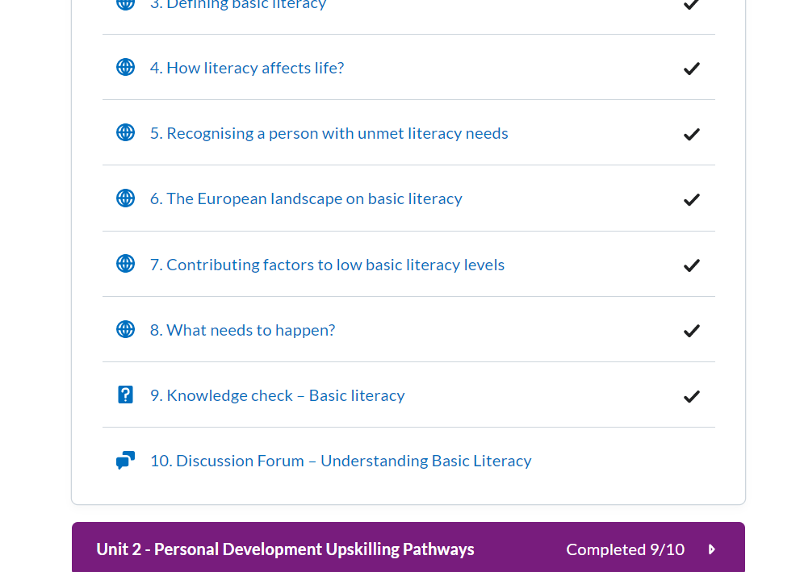

# How to use discussion forums

Click on the Discussion topic and **start a new thread** to edit

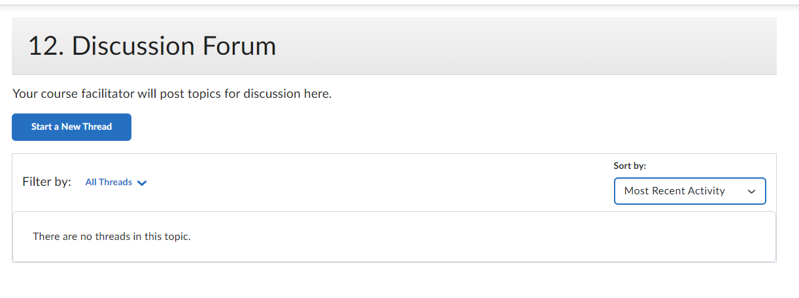

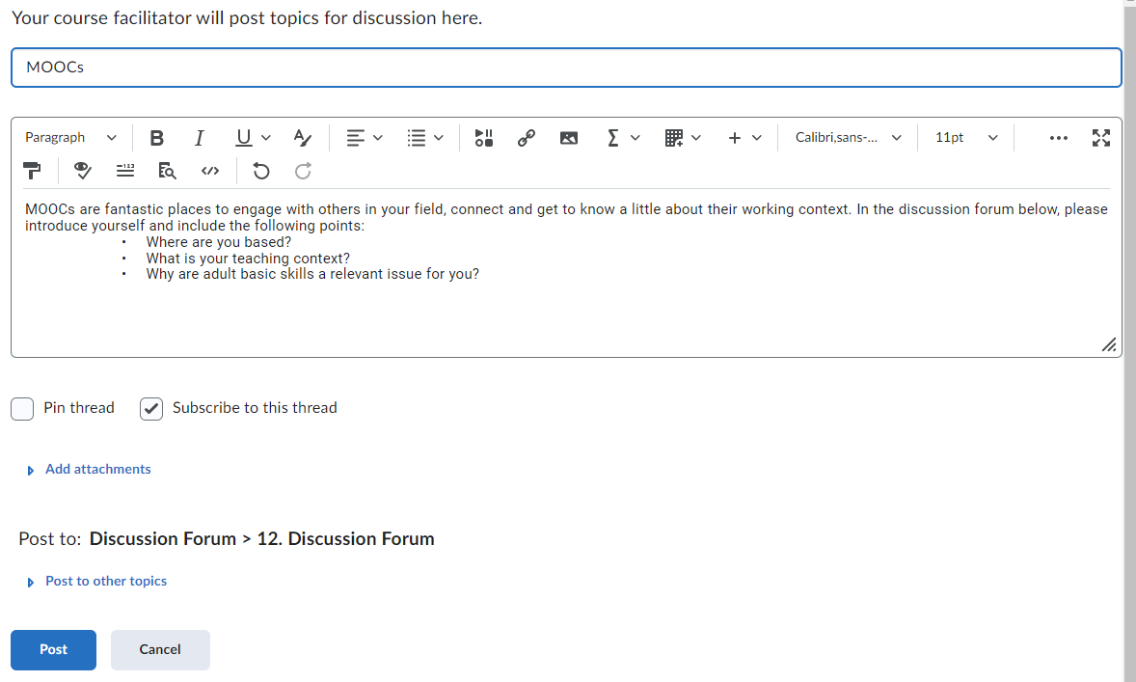

Click **‘post’** to create the topic

# Badges:

Learners will get a Digital badge if they post in each discussion forum. They can either reply to a thread or start their own thread.

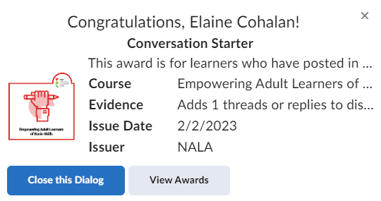

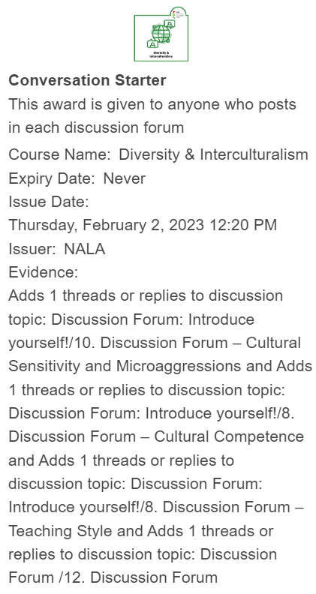

# Possible Issues with Discussion Forums:

As mentioned it above. It is suggested that you only edit the Discussion Forums through the “Content” button and not through Discussions  on the Navbar.

### Hidden Discussion Forums

Discussion forums can be hidden by going to “Discussions” in the Navbar. It is not recommended that you do this. If the Discussion forum isn’t visible it will say “hidden” beneath it. You can make it visible by selecting “Make visible to users”.

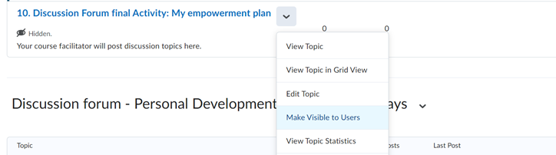

*Unit 1:*

*11.* *Discussion Forum – Digital Tool Evaluation Form*

Topics suggested for discussion:

1. Please post your Digital Tools Evaluation Form here and follow the 4 steps in the activity.

Topics suggested for discussion:

1. MOOCs are fantastic places to engage with others in your field, connect and get to know a little about their working context. In the discussion forum below, please introduce yourself and include the following points:

• Where you are based?

• What your teaching context its?

• Why adult basic skills are a relevant issue for you?

*Unit 2:*

*10. Discussion Forum*

1. Like all modes of education there are advantages and disadvantages associated. Before we look at this topic in depth, in the discussion forum on the next page we would like you to think about any disadvantages of online learning from the following perspectives

Student perspective

Teacher perspective

Technological perspective

2. What do you know about your country's status regarding the implementation of the Upskilling Pathways recommendation?

Look into the Eurydice report on [*Adult education and training in Europe – building inclusive pathways to skills and qualifications*](https://op.europa.eu/en/publication-detail/-/publication/827fcd9c-1a8c-11ec-b4fe-01aa75ed71a1/language-en/format-PDF/source-232128473) for country specific information and European comparison.

3. Which of the three steps of Upskilling Pathways represents the highest challenge in your country?

4. How much do (or could) you apply the three-step approach in your work as a tutor?

5. Look into and take the CITO[SkillsChecker](https://www.skillschecker.ie/)! How relevant and useful do you find this tool? Could you use it in your context?

*Unit 3:*

*10. Discussion Forum*



Topics suggested for discussion:

1. Interaction in online classes is a crucial part of any blended or fully digital courses. As shown in the content of Unit 3, there could be some points for consideration for trainers:

* Talking using microphone
* Turning on webcam
* Writing in the chat box
* Using emojis in the chat box
* Participating in breakout groups
* Answering a poll
* Contributing to a shared document
* Writing on a shared whiteboard

1. Tell us what you think about these points?
2. Do you think they are worth keeping?
3. Which of these do you apply

*Unit 4:*

*11. Discussion Forum*

Submit your storyboard here in any format you choose!

Topics suggested for discussion:

* How do you see the role of the instructor in blended learning courses?
* What are your thoughts on adapting to the online format when teaching?
* What challenges and opportunities will arise?